CS 255 System Design Document Template

This template lays out all the different sections that you need to complete for Project Two. Each section has guidance to prompt your thinking. You will need to continually reference the interview transcript as you work to make sure that you are addressing your client’s needs. There is no required length for the final document. Instead the goal is to complete each section based on what your client’s needs are. Remove this note when you are finished, and replace all bracketed text with the relevant information.

UML Diagrams

UML Use Case Diagram
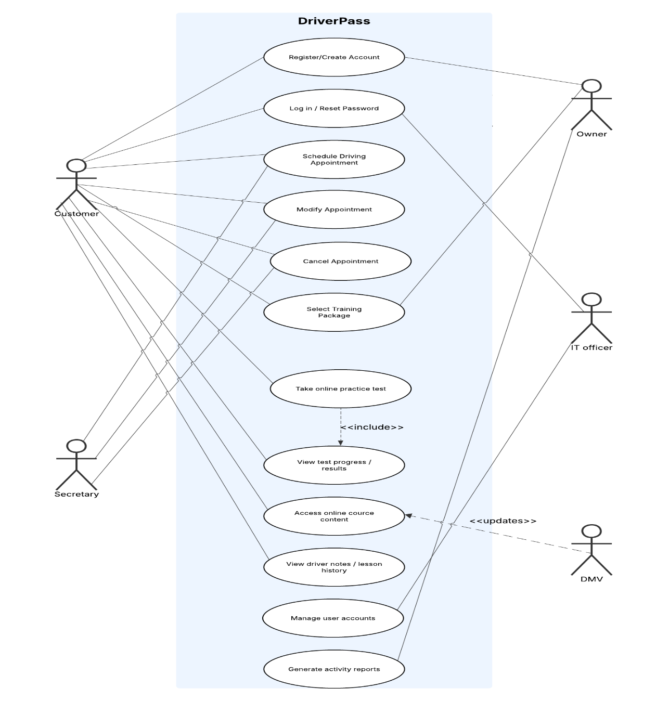

UML Activity Diagrams
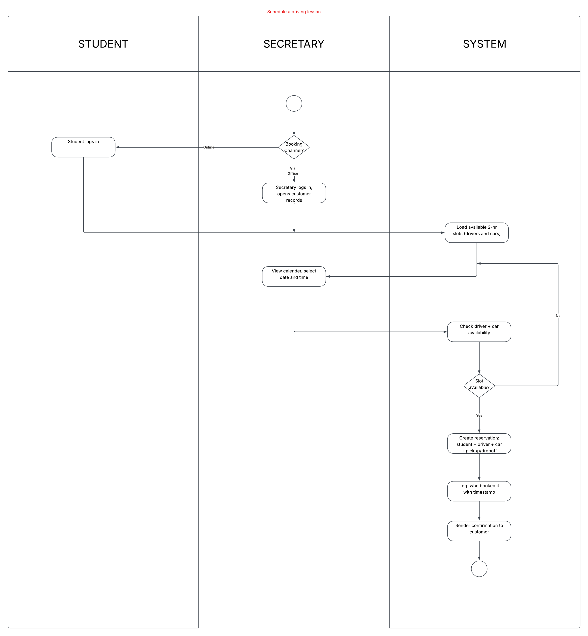
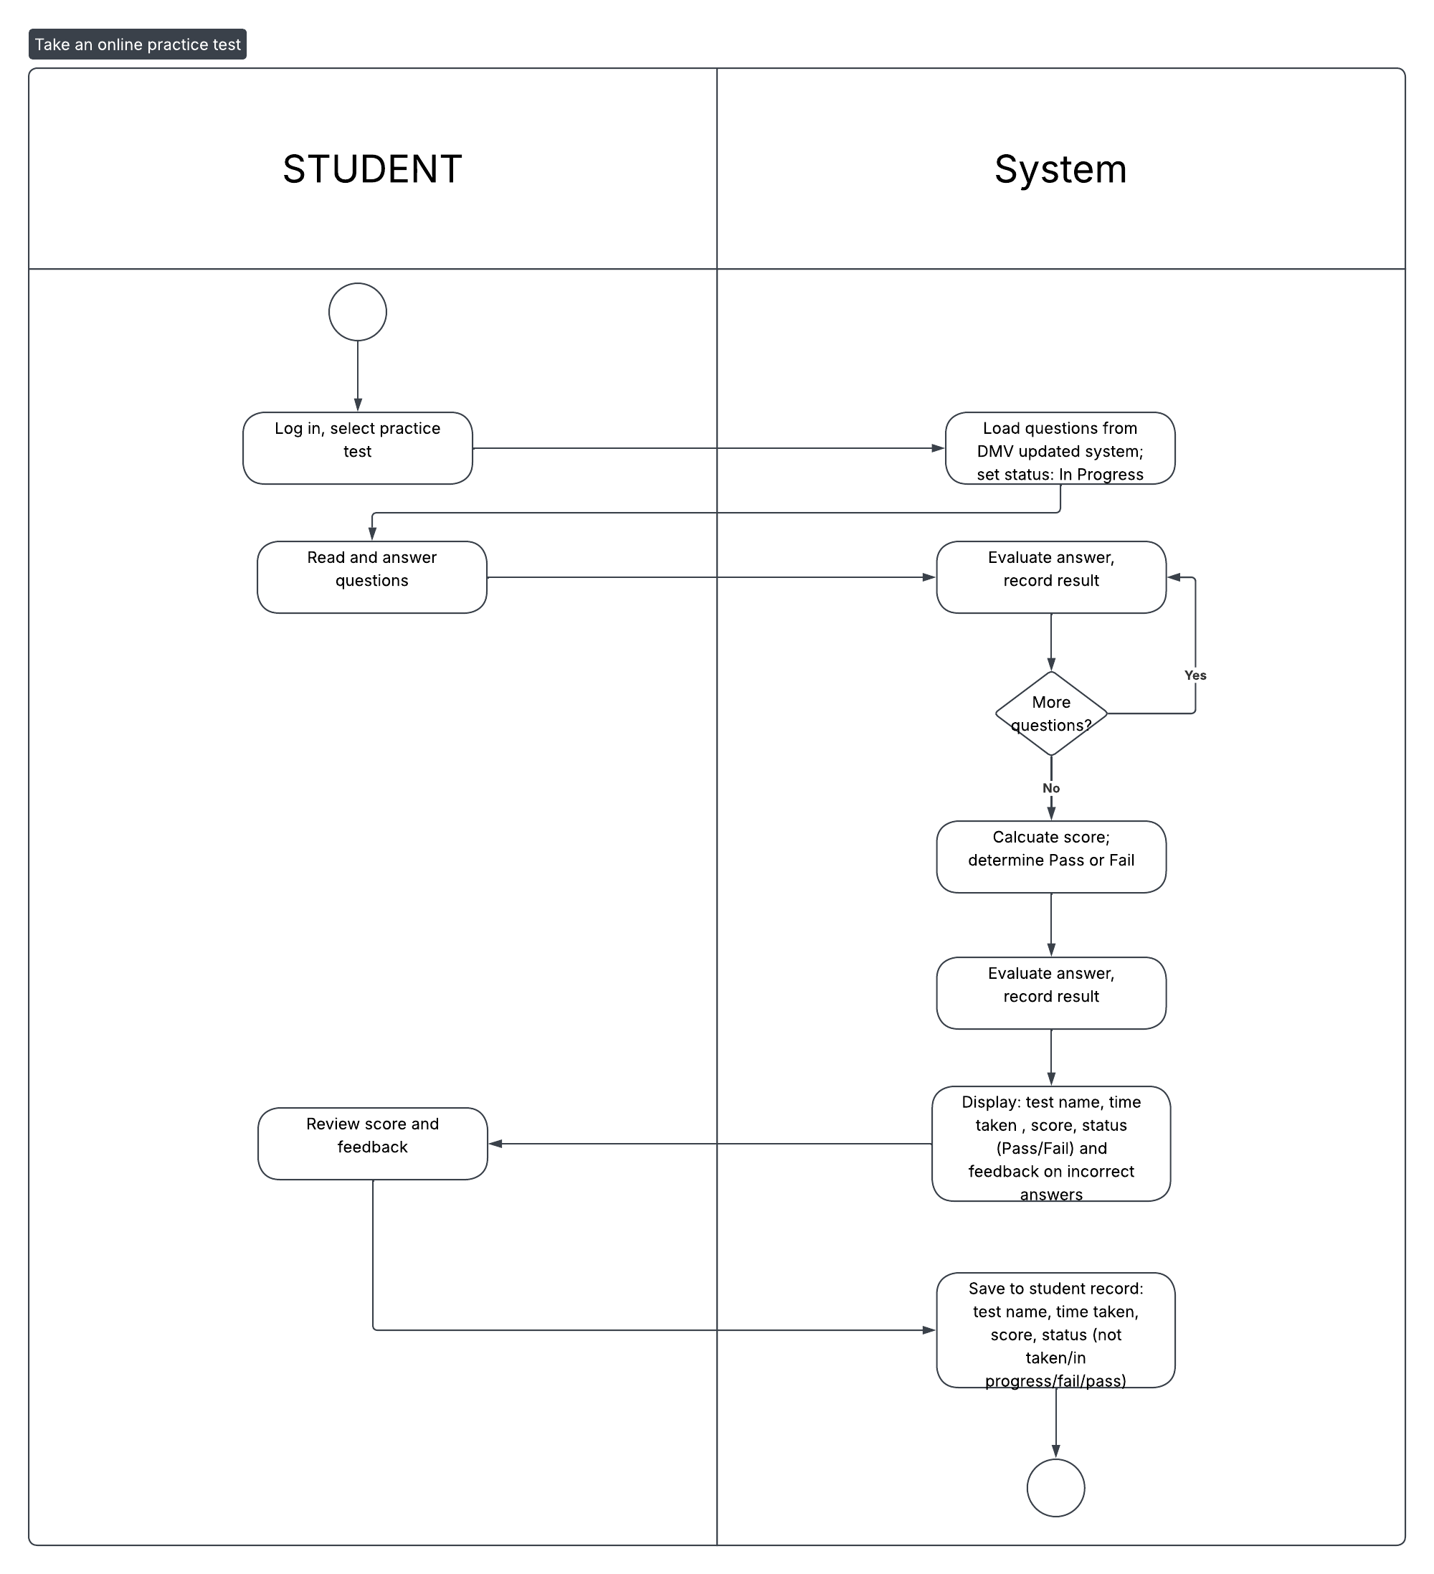

UML Sequence Diagram

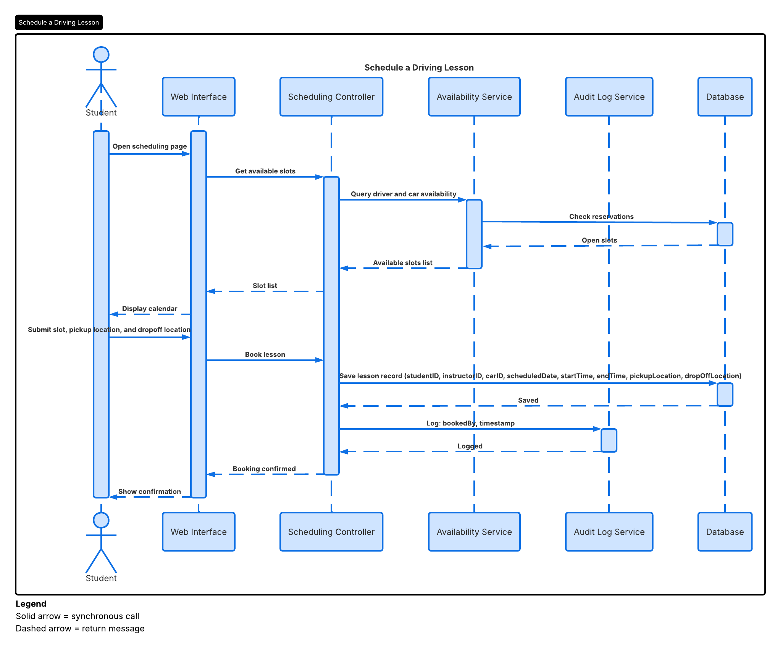

UML Class Diagram

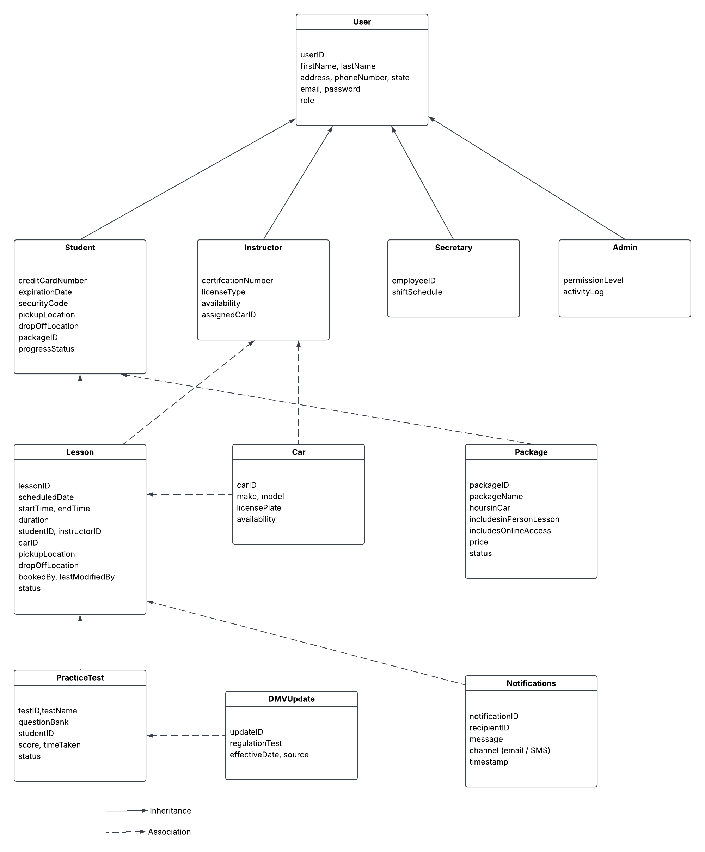

Technical Requirements

Hardware Requirements:
Because the DriverPass system is cloud-hosted, no on-site server hardware is required from the client. The cloud provider will supply and maintain the server infrastructure, including virtual machine instances, storage, and networking hardware. End users, including students, the secretary, the IT officer, and Liam, will access the system through any internet connected device such as a desktop computer, laptop, tablet, or smartphone. Liam specifically mentioned accessing the system from any computer or mobile device, which means the front-end must be fully responsive. Client devices do not require any special hardware beyond a modern web browser and a stable internet connection. The infrastructure layer will require cloud-managed load balancing to distribute traffic and prevent service degradation during peak enrollment periods, as well as redundant storage for report data that Liam indicated he needs to download and work with offline using tools such as Excel.

Software Requirements:

The system will be built as a multi-tier web application. The presentation layer will use a responsive front-end framework to support access from any device type, consistent with Liam’s requirement. The application layer will handle all business logic, including scheduling rules (two-hour session enforcement, driver-car-student matching), package eligibility checks, audit logging, and DMV update processing. The data layer will use a relational database management system to store all structured data, including user accounts, lesson records with full audit fields, car assignments, package enrollments, test results with the status values specified by Liam, and DMV update records. An export feature will allow Liam and other authorized users to download reports in a format compatible with Excel, as requested in the interview. The system will also require integration with a DMV data feed or API to receive regulation updates and sample questions automatically, triggering a notification to administrators when new content is available. Email and SMS notification capabilities will be required to send booking confirmations to customers. Secure HTTPS communication will be enforced across all layers using SSL/TLS certificates. Password reset functionality must be available self-service online for customers, as specified by Ian.

Tools and Infrastructure:

Ian stated directly that the team does not want to deal with backup and security, and that these must be handled by the infrastructure provider. The system will therefore be hosted on a managed cloud platform such as Amazon Web Services, Microsoft Azure, or Google Cloud Platform, which provides automated backup, geographic redundancy, managed security patching, and uptime guarantees. Role-based access control must be implemented to support the distinct permission levels described in the interview: customers can access only their own account and scheduling functions; the secretary can access and manage customer appointments; the IT officer has full access to all user accounts, including the ability to reset passwords and revoke access when an employee leaves; and the owner can access reporting and download activity data. These roles map directly to the User subclasses in the class diagram. A continuous integration and continuous delivery pipeline will be required to support ongoing development and updates to the system without disrupting service. System monitoring and audit logging tools must capture all reservation creation, modification, and cancellation events with user attribution, supporting Liam’s requirement to print activity reports and determine accountability. Data at rest must be encrypted, and automated backup procedures must be in place with recovery objectives sufficient to prevent data loss. The system must be scalable to accommodate growth in the student user base without manual infrastructure changes, which is consistent with Ian’s preference for a system that requires minimal technical involvement from the DriverPass team.

